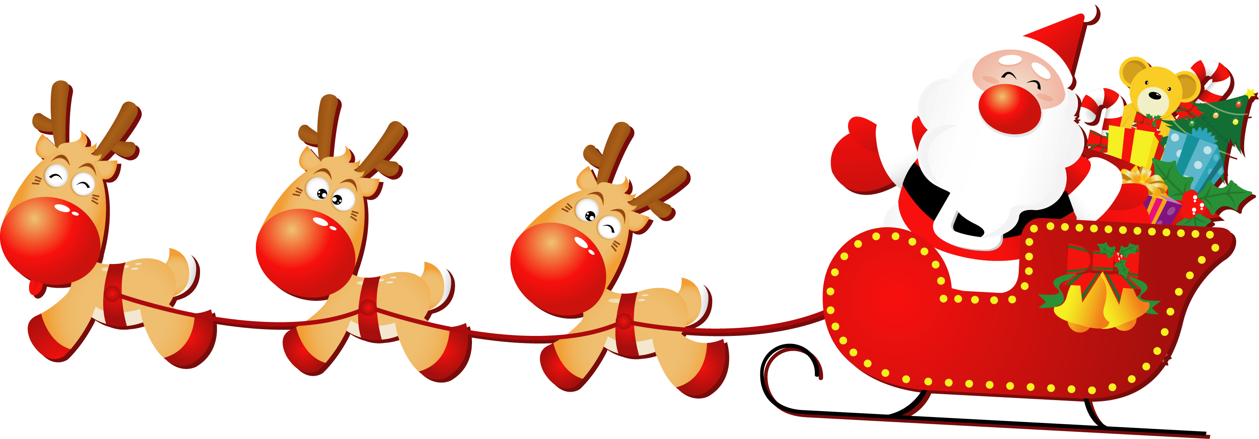

Christmas Celebration 2023
Childcare Services at Queen’s
Dear Parents
To start our festivities this year we will be decorating the Christmas Trees and the Childcare Site from 1st December 2023.
We will be holding the children’s Christmas Party on Wednesday 13th December; again, our staff will ensure the children have a fun time as we partake in the seasonal festivities and we will be wearing our Christmas jumpers. For our Pre-school children, we will be visited by Ellie the ELF at 11.30am. She will chat to the children about litter and recycling and read an exciting story about how Captain Cleanup saved Christmas!
A “Special Visitor” will be calling into Crèche on Friday 15th December 2023. As we all know he is exceptionally busy so could only call with us between 10.00am and 12.00pm. He will be visiting for this short time to speak in person to all children who have been very good this year!
Our staff will be on hand to ensure that everything goes smoothly and can take photographs of your child’s time with Santa Claus. Santa’s Little Helper will upload your child’s photograph onto the APP, so please look out for that!
The staff team will again be wearing their Christmas jumpers for Santa’s visit and if any of the children would like to do this too, they would be more than welcome to join in!!
The Children in the Crèche will also be having their “Christmas Lunch” on Tuesday 19th December – thank you to Mark for arranging this.
Happy Holidays Everyone!

Many thanks
Childcare Staff Team

